- Simplify

  - 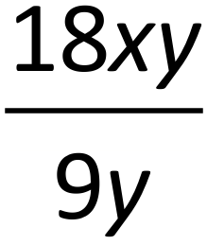
  - 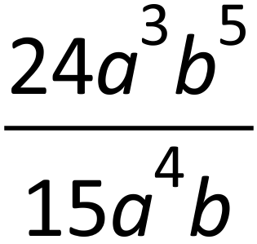
  - 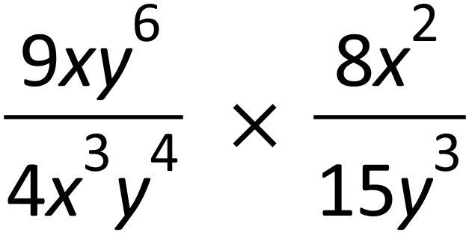

  - 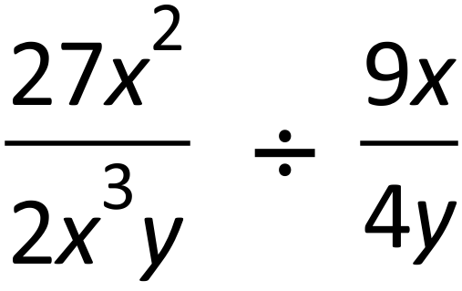
  - 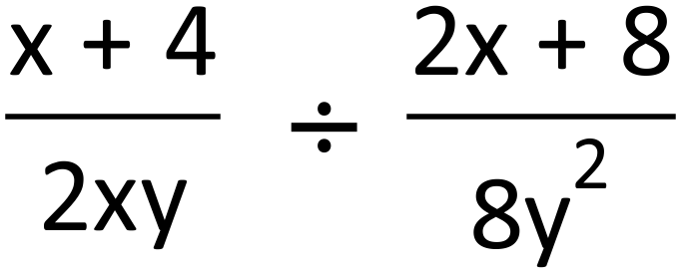
  - 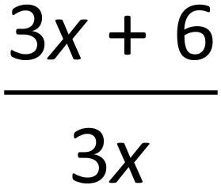
  - 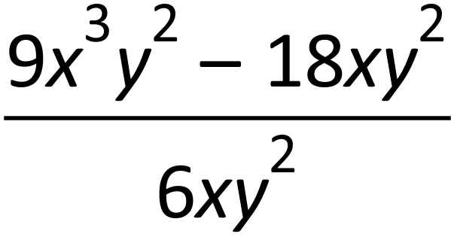
  - 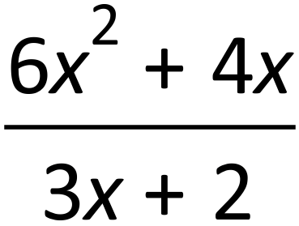
  - 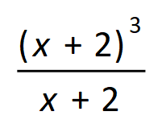

- Write the following as a single fraction

  - 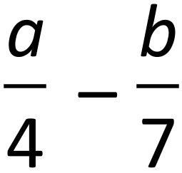
  - 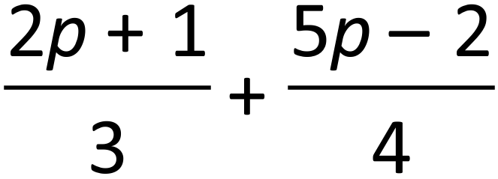
  - 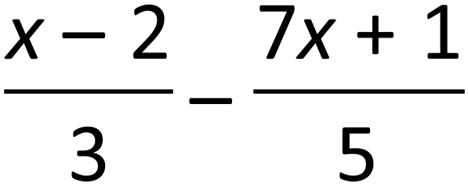

  - 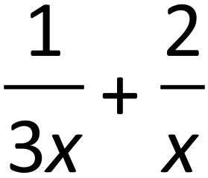
  - 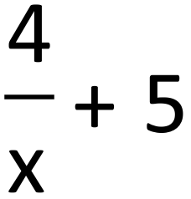
  - 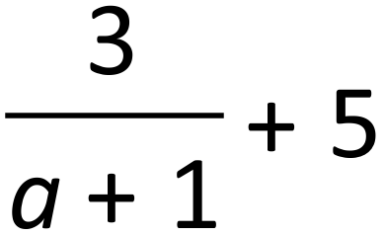
  - 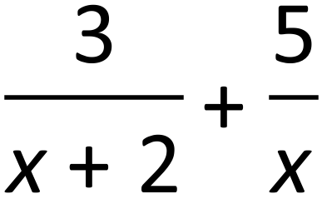
  - 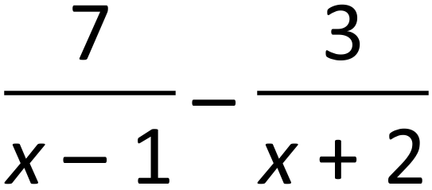
  - 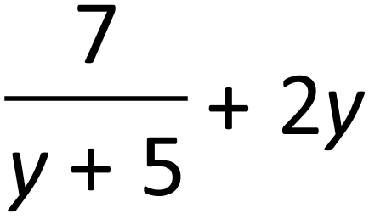

- Solve equations

  - 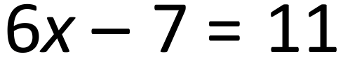
  - 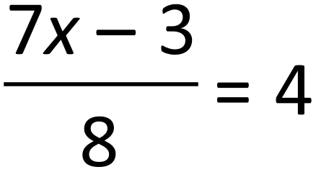
  - 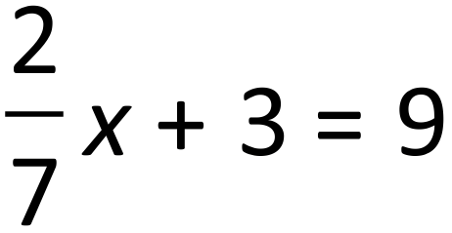
  - 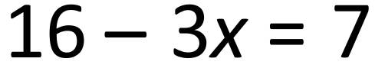

  - 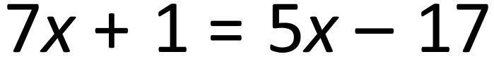
  - 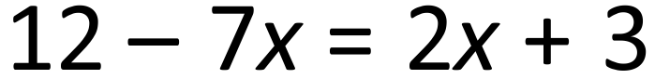
  - 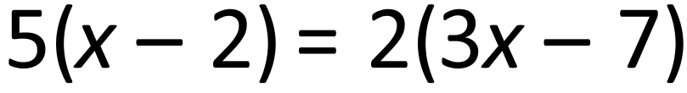
  - 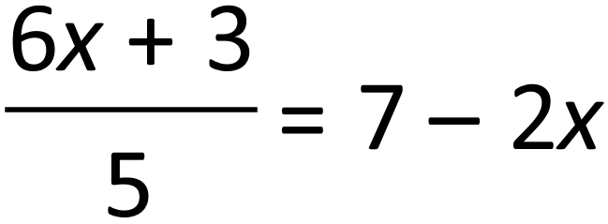
  - 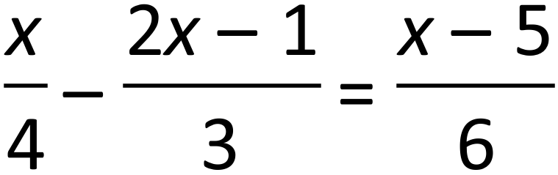
  - 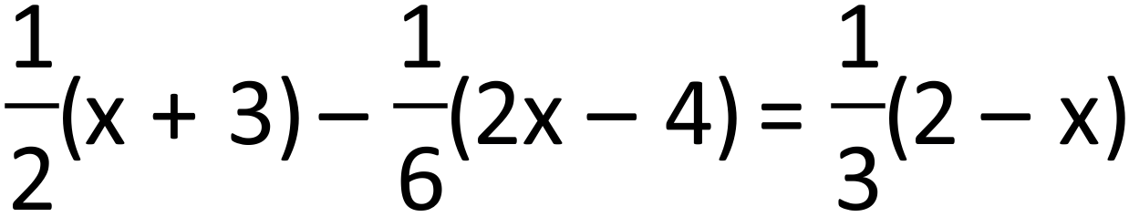
  - 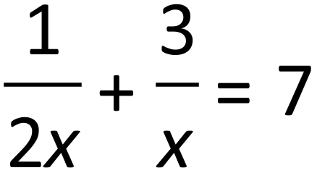
  - 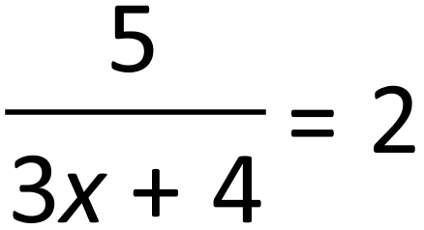
- Solve equations

  - 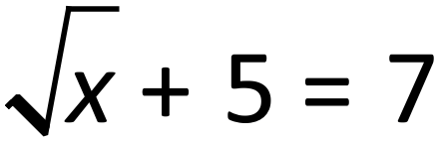
  - 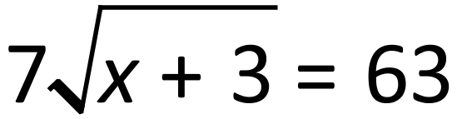
  - 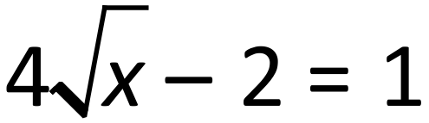
  - 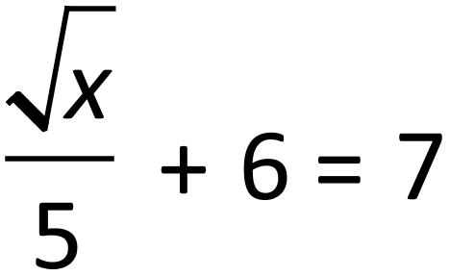
  - 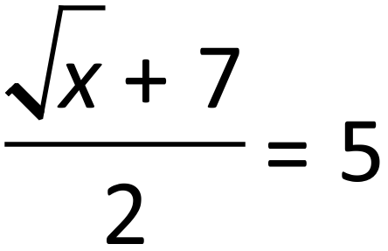
  - 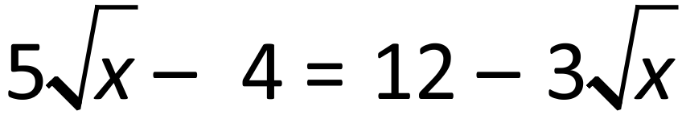
  - 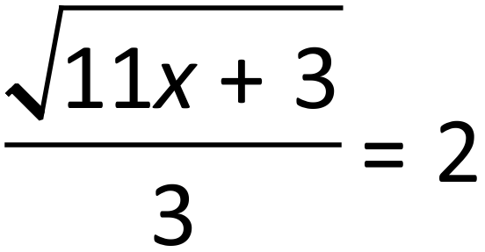
  - 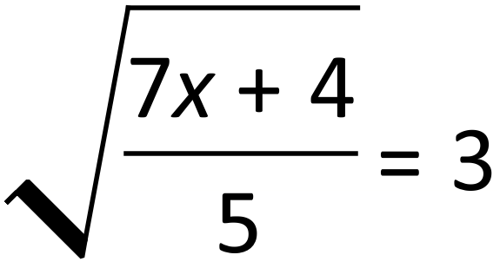
  - 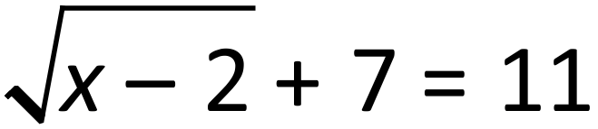
  - 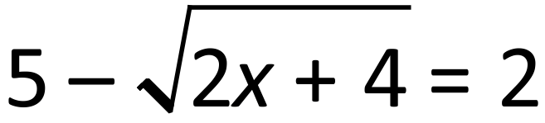

- Solve the following equations

  - 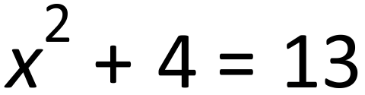
  - 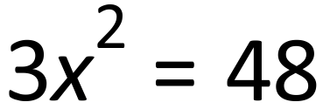
  - 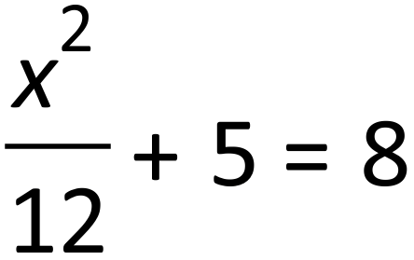
  - 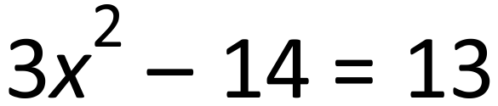
  - 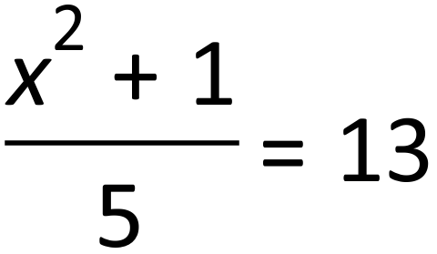
  - 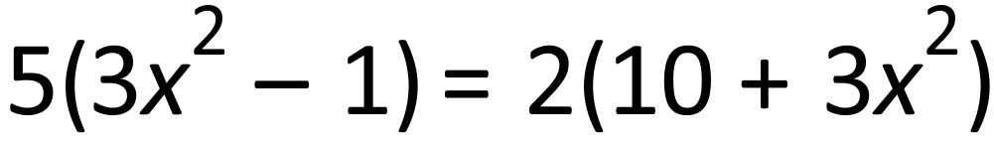
  - 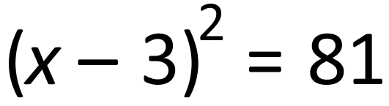
  - 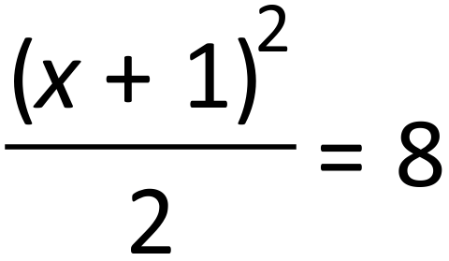
  - 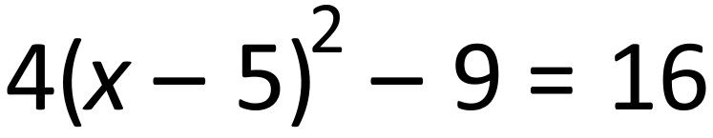
  - 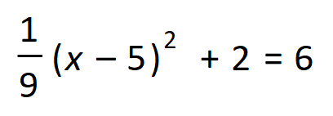
  - 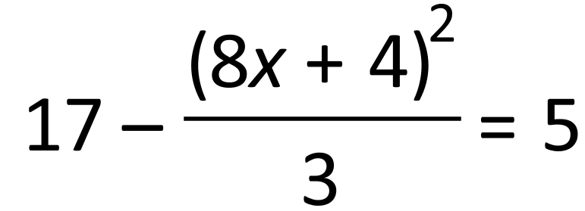
  - 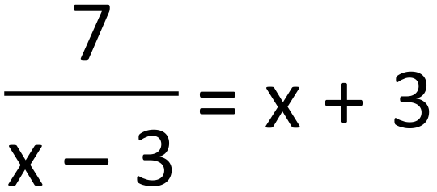

- Solve the following simultaneous equations
  - 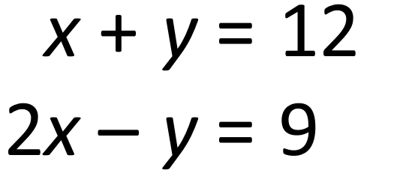
  - 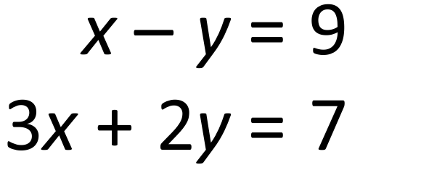

  - 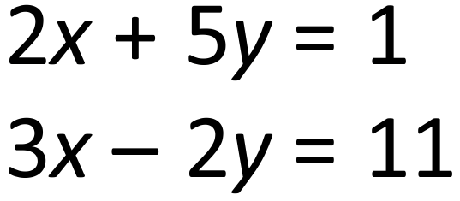
  - 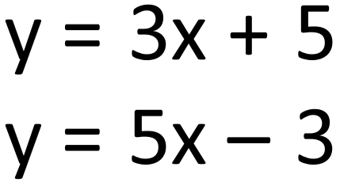

  - 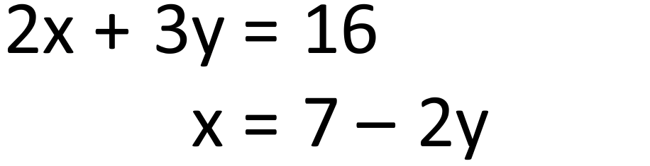
  - 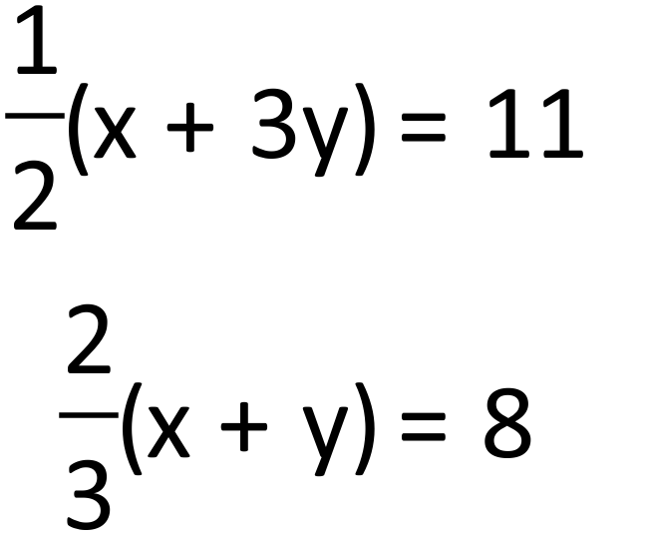

- Factorise fully
  - 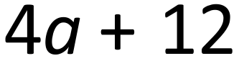
  - 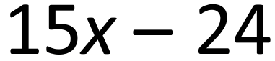
  - 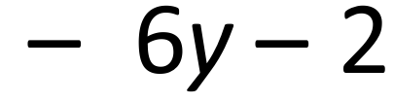
  - 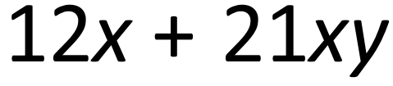

  - 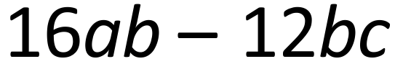
  - 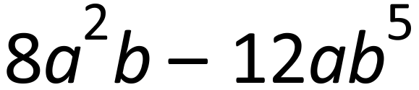
  - 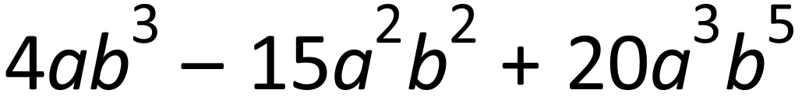
  - 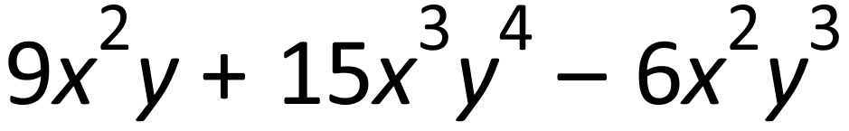
  - 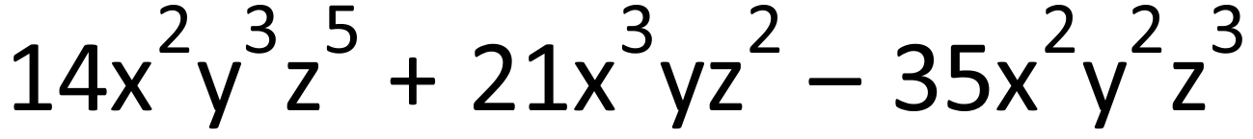
  - 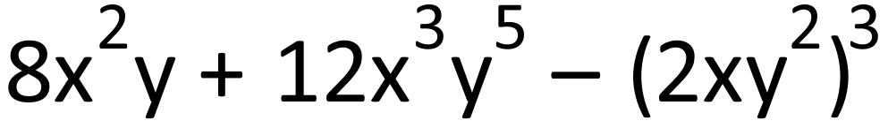
  - 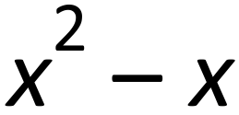
  - 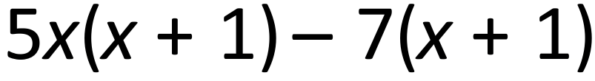

- Solve the inequalities and illustrate the solution on the number line
  - 
  - 
  - 
  - 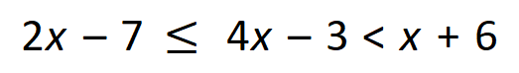

For the Q9 to Q16 set up an equation first and solve it to answer the question.
- Find all the angles of the cyclic quadrilateral.
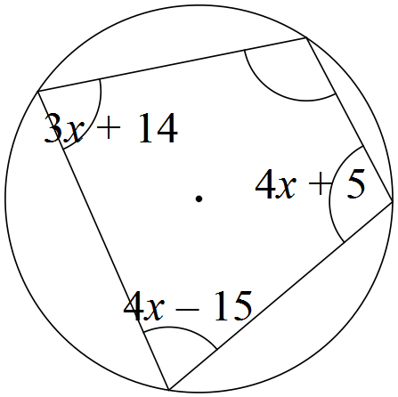

- The length of a rectangle is 5cm more than its width. Find the area of this rectangle if the perimeter is 26cm.

- The sum of four consecutive numbers is 450. Find these numbers.

- A two digit number is increased by 27 when the digits are reversed and the sum of the digits is 7. Find the original number.

- Simon and Josh have £44 together. If Simon’s money is doubled and Josh’s tripled they will have £109 altogether. How much does each boy have?

- Henry participates in 10K charity run (10 km). He runs some of it at 12km/h and walks the rest of the way at 4 km/h. He finishes in 1 hour. For how long and what distance did Henry run?

- A book of 45 postage stamps contains both 1st and 2nd class stamps at price 62p for a 1st class and 53p for a 2nd class stamp. How many 1st class stamps are in the book if it costs £27.

